**KGiSL Institute Of Technology**

**Computer Science Department**

**Final Year Project:**

**Zeroth Review**

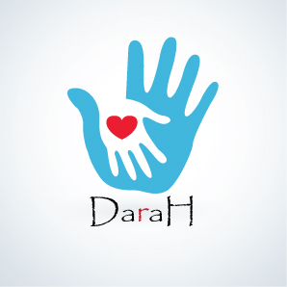

**Abstract:**

**Darah** (My Blood Circle App):

Darah is a mobile application which is used for finding blood donors and becoming donors for blood donation. This is very useful application which enables for a good cause to save lives.

In this application, we help people in finding donors nearby and in particular area. We also volunteer people who are willing to donate blood to others. Donors will be creating their own profile in this app where they will fill in up all the essential information regarding their blood group and personal details for others to communicate them. All the donors will be categorized by their blood groups so that blood finders will be able to search for particular blood easily. People will also get information regarding the nearby blood banks for easy access of blood.

In our application, we set certain constrains for people who wish to donate blood. There are certain body conditions to be maintained before donating blood. If the particular person does not satisfy the conditions then that person will be alerted before donating blood.